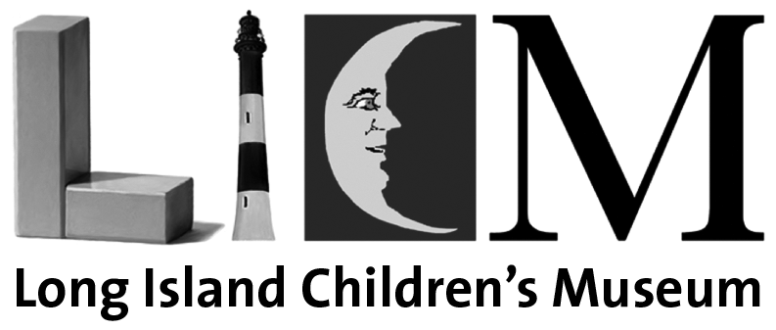

Contact: Maureen P. Mangan
Direct Line: 1-516-224-5828

PHARMACEUTICAL EXECUTIVE JOINS LONG ISLAND CHILDREN’S MUSEUM BOARD

GARDEN CITY, NY – Genevieve DellaFera, Manager of Business Development at Fera Pharmaceuticals, has joined the Board of Trustees of the Long Island Children’s Museum. DellaFera, a resident of Lattingtown, was elected to a three-year board term.
In announcing the appointment, LICM President Erika S. Floreska said, “We are thrilled to welcome Genevieve DellaFera to the Board of Trustees. She brings to this new role the energy and passion she has consistently demonstrated through her work as a committee member and as the dynamic auction chair for our Cupcakes & Cocktails fundraiser, which just raised a record $1 million to sustain the Museum programs and exhibits. Combined with the strategic focus she’s developed professionally, Genevieve will be an invaluable asset as we advance our mission to inspire and engage children and families across Long Island through the power of play/through playful learning.”
“As a parent, I believe it is deeply important for children to have opportunities to connect with one another within our community,” said Genevieve DellaFera. “LICM provides an essential space where children from across Long Island can come together to celebrate, discover, and play.”

DellaFera brings over 16 years of experience in the pharmaceutical industry, where she led business development and regulatory initiatives at Fera Pharmaceuticals. As Manager of Business Development, she developed and executed growth strategies that strengthened the company’s competitive position.

Her background spans both business development and regulatory affairs, offering a comprehensive perspective on innovation, compliance, and industry growth. She holds a degree from Villanova University and a J.D. from St. John’s University, combining business acumen with legal expertise.

About the Long Island Children's Museum (www.licm.org)
The mission of Long Island Children's Museum (LICM) is to connect all our communities' children, and those who care for them, to a life of wonder, imagination and exploration. At LICM, children discover their passions and their relationship to the world we share. The 40,000-square-foot museum serves over 300,000 children and adults annually. The private, not-for-profit institution chartered by the New York State Board of Regents, offers museum-based educational programs and cultural experiences, as well as an extensive community outreach program offered in schools, libraries and youth centers across Long Island.

Recognized with several honors, including the National Medal from the Institute of Museum and Library Services (IMLS), LICM is accredited by the American Alliance of Museums (AAM), the gold standard of museum excellence. It is currently the only accredited children's museum in New York State and is one of only 16 accredited children's museums nationwide. LICM has earned 4 stars on Charity Navigator and has Platinum Transparency on Candid.

Photo Caption:
Genevieve DellaFera joins LICM Board of Trustees

